Product/Project One-Pager

One-pager documents are meant to be collaborative between Product members, UX, and development. Typically, these documents should be started at the beginning of any project kick-off or as soon as the problem is hypothesized or known. This way all members can help build the supporting information like user flow, pain-points, etc.

* Project Title & Description?
* Problem: What problem is this solving?
* Why: How do we know this is a real problem and worth solving?
* Success: How do we know if we’ve solved this problem?
* Audience: Who are we building for?
* Competitors: Who, if any?
* Must-haves: What’s mandatory in version 1.0 for this initiative to achieve the goal?
* Out-of-Scope: Are there areas where scope creep could become an issue?

Project Title & Description

Voyager Study System

A system designed to make it easier to collect, manage, and use clinical trial data for exploratory research​.

Problem: What problem is this solving?

Remote Monitoring isn’t Possible

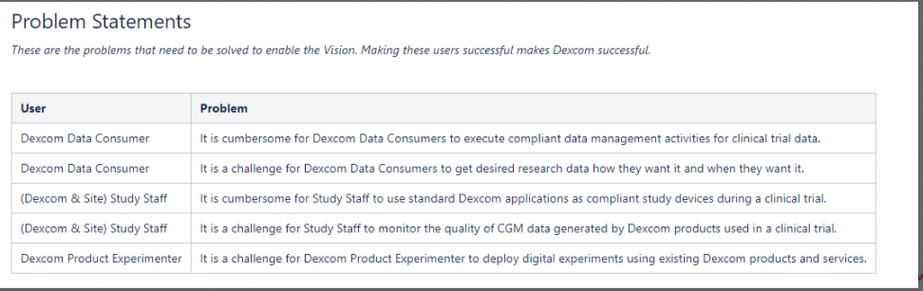

Why: How do we know this is a real problem and worth solving?

Success: How do we know if we’ve solved this problem?

Audience: Who are we building for?

Dexcom Staff – Dexcom Study and Site Leads (role?)

Site Staff – Interface with Study Subjects (role)

Data Consumer – Dexcom Data Scientist, Algo Engineers, Human Factors, etc.

Product Experimenter – Dexcom Data Scientist, Machine Learning Developers, etc.

Study Subject – A patient participating in a Study (Have Diabetes?)

Web Portal Administrator – Dexcom Software Engineer

Competitors: Who, if any?

Must-haves: What’s mandatory in version 1.0 for this initiative to achieve the goal?

Out-of-Scope: Are there areas where scope creep could become an issue?

User Story

# A user story is short, specific and goal oriented. It is a one-sentence statement that tends to have the following structure: “As a,… I want,… so that… ”. User stories are collaborative design tools. User stories focus the project on the perspective of those who will use it.

* "As a..."

The role refers to the one who makes the action and who benefits.

* "I want..."

It is the action executed.

* "So That... "

It is the added value that the user gets from the action.